Division |  | Name | Signature | Date
Prepared By | ARD
Reviewed By | ARD
 | DQA
Approved By | ARD
 | DQA
Authorized By | Head R&D

REVISION SUMMARY

Revision Number | Effective Date | Reason for Revision
00 |  | New STP.

Note
RIT-S3 is highly hygroscopic and should be sampled under a nitrogen atmosphere.

- RELATED SUBSTANCES
(By GC-AS)

Chromatographic conditions
A gas chromatograph equipped with FID and integrator and auto sampler.

Column : ZB-5 (30 m x 0.53 mm, 5.0 µm)
Column part number : 7HK-G002-39
Injector temperature : 180 °C
Detector temperature : 260 °C
Split ratio : 15:1
Column flow : 4.5 mL/minute
Linear velocity : 34.257 cm/sec
Carrier gas : Nitrogen
Diluent : Dichloromethane
Injection volume : 1.0 µL
Run time : 33 minutes

Oven temperature : Initially hold at 50 °C for 5 minutes, then increase the temperature to
120 °C at the rate of 15 °C/minute, and hold at 120 °C for 4 minutes,
further increase the temperature to 240 °C at the rate of 15 °C/minute,
and hold at 240 °C for 11.34 minutes.

Needle wash : Dichloromethane

Blank solution
Use diluent as blank

Impurity stock solution-1
Accurately weigh about 25 mg of RIT-S3 Impurity-D, RIT-S3 Impurity-E, RIT-S3 Impurity-F, RIT-S3 Impurity-H reference/ working standards into a 25 mL volumetric flask containing about 10 mL of diluent, shake well to dissolve and dilute to volume with diluent. Shake well to mix.

Impurity stock solution-2
Accurately weigh about 50 mg of RIT-S3 Impurity-C reference/ working standard into a 20 mL volumetric flask, containing about 10 mL of diluent. Add 5 mL of impurity stock solution-1 to it dissolve and dilute to volume with diluent. Shake well to mix.

System suitability solution
Accurately weigh about 250 mg of RIT-S3 reference/working standard into a 5 mL volumetric flask containing about 2 mL of diluent to it. Add 1.0 mL of Impurity stock solution-2 and dilute to volume with diluent. Shake well to mix.

Sample solution
Accurately weigh about 250 mg of sample into a 5 mL volumetric flask containing about 2 mL of diluent, shake well to dissolve and dilute to volume with diluent. Shake well to mix.

Solution stability (As per development data)
- System suitability solution is stable up to 40 hours at 25°C
- Sample solution is stable up to 40 hours at 25°C

Procedure
Set up the gas chromatograph with the conditions described above and allow the system and the column to equilibrate. Run the system as per the injection sequence given below. Record the chromatograms and measure the peak responses. Apply the blank correction in case of any interference from the solvent used as diluent.

Injection sequence

Name of the solution | No. of injections
Blank | 1
System suitability solution | 1
Blank | 1
Sample solution | 1
System suitability solution- Bracketing | 1

System suitability criteria
- The USP plate count for RIT-S3 peak as obtained in the chromatogram of system suitability solution should not be less than 10000.
- The USP tailing for RIT-S3 peak as obtained in the chromatogram of system suitability solution should not be more than 2.0.

The retention time (RT), relative retention time (RRT), relative response factor (RRF), limit of detection (LOD) and limit of quantitation (LOQ) has been tabulated below as per development data-

Name of component | RT (minutes) | RRT | RRF | LOD (% w/w) | LOQ (% w/w)
RIT-S3 Impurity-C | ~ 6.41 | ~ 0.56 | 0.89 | 0.08 | 0.24
RIT-S3 Impurity-H | ~ 9.51 | ~ 0.83 | 0.78 | 0.01 | 0.03
RIT-S3 | ~ 11.53 | 1.00 | 1.00 | 0.01 | 0.03
Impurity at RRT 1.21 | - | ~ 1.21 | - | - | -
RIT-S3 Impurity-E | ~ 16.66 | ~ 1.45 | 2.56 | 0.01 | 0.03
RIT-S3 Impurity-D | ~ 17.83 | ~ 1.55 | 2.10 | 0.01 | 0.03
RIT-S3 Impurity-F | ~ 19.99 | ~ 1.73 | 1.61 | 0.01 | 0.03
Impurity at RRT 1.96 | - | ~ 1.96 | - | - | -

Calculation (%)

$$\% Impurity=\frac{\% Area of Impurity by area normalization}{RRF}$$

- ASSAY
(By GC-AS)

Chromatographic conditions
A gas chromatograph equipped with FID, integrator and auto sampler.

Column : ZB-5 (30 m x 0.53 mm, 5.0 µm)
(Part number: 7HK-G002-39)
Injector temperature : 180 °C
Detector temperature : 260 °C
Split ratio : 15:1
Column flow : 4.5 mL/ minute
Linear velocity : 34.257 cm/sec
Carrier gas : Nitrogen
Injection volume : 1.0 µL
Diluent : Internal standard

Retention time : The retention time of Toluene and RIT-S3 derivative peaks are
about 10.2 minutes and 11.9 minutes respectively.

Oven temperature : Initially hold at 50 °C for 5 minutes, then increase the temperature to 120 °C at the rate of 15 °C/minute and hold at 120 °C for 4 minutes. Further increase the temperature to 240 °C at the rate of 30 °C/minute and hold at 240 °C for 2.33 minutes.

Blank
Use diluent as blank.

Internal standard solution
Accurately weigh about 825 mg of toluene standard into a 500 mL volumetric flask containing 10 mL of methanol and dilute to volume with methanol. Shake well to mix.

Standard solution
Accurately weigh about 250 mg of RIT-S3 reference/ working standard into a 50 mL volumetric flask containing 10 mL of diluent and dilute to volume with diluent. Shake well to mix.

Sample solution (Duplicate Preparation)
Accurately weigh about 250 mg of sample into a 50 mL volumetric flask containing 10 mL of diluent and dilute to volume with diluent. Shake well to mix.

Solution stability
The standard solution and sample solutions are stable up to 7 hours at 25 °C as per development data.

Procedure
Set up the gas chromatograph with the conditions described above and allow the system and the column to equilibrate. Run the system as per the injection sequence given below. Record the chromatograms and measure the peak responses. Integrate the peaks due to Toluene and RIT-S3 Derivative in standard and sample solutions.

Injection sequence

Name of the solution | No. of injections
Blank | 1
Standard solution | 6
Blank | 1
Sample solution-1 | 1
Sample solution-2 | 1
Standard solution - Bracketing | 1

System suitability criteria
- The USP plate count for RIT-S3 Derivative peak as obtained in the chromatogram of first injection of standard solution should not be less than 10000.
- The % RSD of area ratio of RIT-S3 Derivative and Toluene peaks as obtained from six replicate
injections of standard solution should not be more than 2.0.
- The similarity factor for sample solution-2 with sample solution-1 should be greater than or
equal to 0.98 and should be less than or equal to 1.02.
Calculation (% w/w)

Calculate the similarity factor for sample solutions as per the formula given below:

$$Sample solution$$

$$= \frac{Area ratio of sample solution-2}{Area ratio of sample solution-1}×\frac{Weight of sample in sample solution-1}{Weight of sample in sample solution-2}$$

Calculate the assay by using the following formula:

$$Assay (as such basis)= \frac{Area ratio of sample}{ Average area ratio of standard}×\frac{W_{S}}{W_{T}}×P$$

Area ratio of sample = $\frac{Area of RIT-S3 derivative in sample solution}{Area of Toluene in sample solution}$

Area ratio of standard = $\frac{Area of RIT-S3 derivative in standard solution}{Area of Toluene in standard solution}$

Where,
W_{S} : Weight of RIT-S3 reference/ working standard in standard solution (mg).
W_{T} : Weight of the sample (mg).
P : Potency/Purity of RIT-S3 reference/ working standard.

Note: The result of individual sample solution preparation should be within acceptance criteria.

Reporting of result

$$Result=Result of assay from \frac{(sample solution-1+sample solution-2)}{2}$$

Figure 1 : Typical chromatogram of system suitability solution in the test for related substances by
GC-AS.

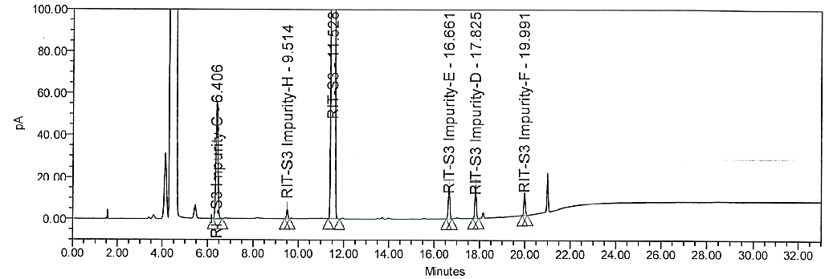

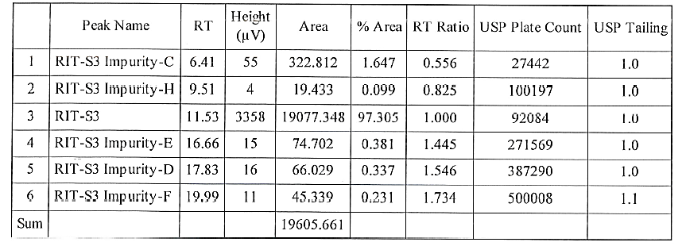

Figure 2 : Typical chromatogram of standard solution in the test for assay by GC-AS.

